# PREDICTING PERSONAL LOAN APPROVAL USING MACHINE LEARNING

### Submitted in partial fulfillment of the requirements for the award of the degree of

### BACHELOR OF SCIENCE

### IN

### COMPUTER SCIENCE

# TEAM MEMBERS

### SUGANYA K (REG NO:10320U18061)

### SUBASRI L(REG NO:10320U18060)

### SWATHI A(REG NO:10320U18063)

### SWETHA S(REG NO:10320U18066)

# Under the Guidance of

### Dr. S. MANIKANDAN M.Sc.,M.C.A.,M.Phil,B.Ed.,P.G.Dip.Yoga, Ph.D.,

### ASSISTANT PROFESSOR

### UG DEPARTMENT OF COMPUTER SCIENCE



### UG DEPARTMENT OF COMPUTER SCIENCE GOVT.ARTS COLLEGE, CHIDAMBARAM – 608 102 (Affiliated to Thiruvalluvar University, Annamalai Nagar)

# PREDICTING PERSONAL LOAN APPROVAL USING MACHINE LEARNING

# INTRODUCTION

# OVERVIEW

# A loan is a sum of money that is borrowed and repaid over a period of time, typically with interest. There are various types of loans available to individuals and businesses, such as personal loans, mort gages, auto loans, student loans, business loans and many more. They are offered by banks, credit unions, and other financial institutions, and the terms of the loan, such as interest rate, repayment period, and fees, vary depending on the lender and the type of loan.A personal loan is a type of unsecured loan that can be used for a variety of expenses such as home repairs, medical expenses, debt consolidation, and more. The loan amount, interest rate, and repayment period vary depending on the lender and the borrower's credit worthiness .To qualify for a personal loan, borrowers typically need to provide proof of income and have a good credit score. Predicting personal loan approval using machine learning analyses a borrower's financial data and credit history to determine the likelihood of loan approval. This can help financial institutions to make more informed decisions about which loan applications to approve and which to deny.

# PURPOSE : Loan Prediction is very helpful for employee of banks as well as for the applicant also. The aim of this Paper is to provide quick, immediate and easy way to choose the deserving applicants. Dream housing Finance Company deals in all loans. They have presence across all urban, semi urban and rural areas. Customer first apply for loan after that company or bank validates the customer eligibility for loan. Company or bank wants to automate the loan eligibility process (real time) based on customer details provided while filling application form. These details are Gender, Marital Status, Education, Number of Dependents, Income, Loan Amount, Credit History and other. This project has taken the data of previous customers of various banks to whom on a set of parameters loan were approved. So the machine learning model is trained on that record to get accurate results. Our main objective of this project is to predict the safety of loan. To predict loan safety, the SVM and Naïve bayes algorithm are used. First the data is cleaned so as to avoid the missing values in the data set.

# PROBLEM DEFINING AND DESIGN THINKING

# EMPATHY MAP

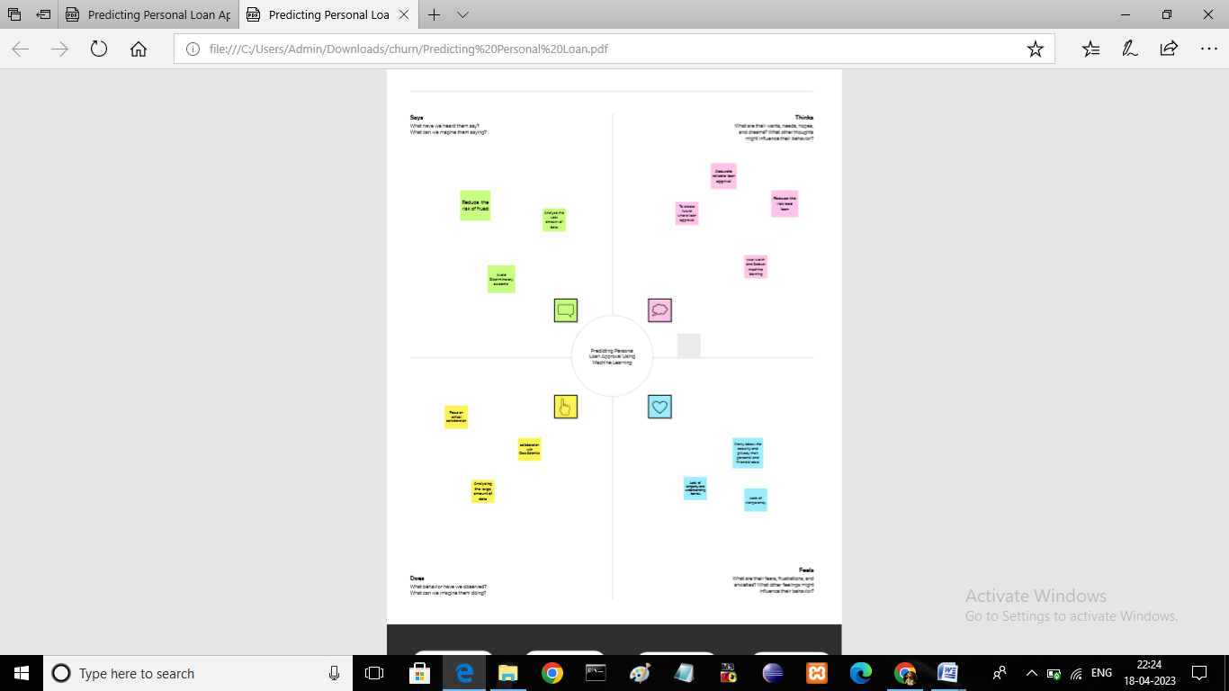

## IDEATION &BRAINSTROMING MAP

## Screenshot (33).png

### ADVANTAGES

### Accuracy—one of the primary benefits of using machine learning for credit scoring is its accuracy. Unlike human manual processing, ML-based models are automated and less likely to make mistakes. This means that loan processing becomes not only faster but more accurate, too, cutting costs on the whole.

### It is done by predicting if the loan can be given to that person on the basis of various parameters like credit score, income, age, marital status, gender, etc. The prediction model not only helps the applicant but also helps the bank by minimizing the risk and reducing the number of defaulters.

### Using historical data, machine learning algorithms can learn to identify trends and patterns to evaluate possible outcomes. Using this as its reference framework, the algorithm can repeat the process with current data to make predictions about the future

### Machine learning allows banks to proactively monitor customer behavior, identify anomalies in real time, reduce the probability of false positives, and prevent fraud. Machine learning's ability to model how a bank will react to certain economic conditions allows decisionmakers to create more informed strategies.

### 

### 

### DISADVANTAGES

### The disadvantage of this model is that it emphasize different weights to each factor but in real life sometime loan can be approved on the basis of single strong factor only, which is not possible through this system.

### Loans are not very flexible - you could be paying interest on funds you're not using. You could have trouble making monthly repayments if your customers don't pay you promptly, causing cashflow problems

### Strict eligibility criteria. One of the major disadvantages of a bank loan is that banks can be cautious about lending to small businesses.

### Inaccuracies are a common occurrence since algorithms and can sometimes be underdeveloped. Indeed human is to error, and since a human makes these algorithms, mistakes in the coding may be overlooked

### Risk of hacking and scams- Be careful about the data you share and the online loan apps you use, as these can be prone to data hacking since the whole loan process is done online.

### APPLICATION

### 

### Loan Approval System is software used for approval of loan in banking sector. In this proposed system we have used machine learning algorithm. Machine Learning is process in which a symmetric model is build from the existing dataset; this model is applied for the testing of the new dataset.

### It is done by predicting if the loan can be given to that person on the basis of various parameters like credit score, income, age, marital status, gender, etc. The prediction model not only helps the applicant but also helps the bank by minimizing the risk and reducing the number of defaulters.

### Machine learning model predictions allow businesses to make highly accurate guesses as to the likely outcomes of a question based on historical data, which can be about all kinds of things – customer churn likelihood, possible fraudulent activity, and more.

### 

### CONCLUSION

### From the proper view of analysis this system can be used perfect for detection of clients who are eligible for approval of loan. The software is working perfect and can be used for all banking requirements. This system can be easily uploaded in any operating system. Since the technology is moving towards online, this system has more scope for the upcoming days. This system is more secure and reliable. Since we have used Random Forest Algorithm the system returns very accurate results. There is no issue if there are many no of customers applying for loan. This system accepts data for N no. of customers. In future we can add more algorithms to this system for getting more accurate results.

### APPENDIX

### SOURCE CODE

import pandas as pd

train_df = pd.read_csv(r'C:\Users\sridh\OneDrive\Desktop\new project\dataset\train_u6lujuX_CVtuZ9i.csv') train_df.info() train_df = train_df.drop(columns=['Loan_ID']) ## Dropping Loan ID categorical_columns = ['Gender', 'Married', 'Dependents', 'Education', 'Self_Employed', 'Property_Area','Credit_History','Loan_Amount_Term'] #categorical_columns = ['Gender', 'Married', 'Dependents', 'Education', 'Self_Employed', 'Property_Area','Loan_Amount_Term']

print(categorical_columns) numerical_columns = ['ApplicantIncome', 'CoapplicantIncome', 'LoanAmount'] print(numerical_columns)

import seaborn as sns import matplotlib.pyplot as plt

fig,axes = plt.subplots(4,2,figsize=(12,15)) for idx,cat_col in enumerate(categorical_columns): row,col = idx//2,idx%2 sns.countplot(x=cat_col,data=train_df,hue='Loan_Status',ax=axes[row,col])

plt.subplots_adjust(hspace=1)

fig,axes = plt.subplots(1,3,figsize=(17,5)) for idx,cat_col in enumerate(numerical_columns): sns.boxplot(y=cat_col,data=train_df,x='Loan_Status',ax=axes[idx])

print(train_df[numerical_columns].describe()) plt.subplots_adjust(hspace=1)

train_df_encoded = pd.get_dummies(train_df,drop_first=True) train_df_encoded.head()

train_df_encoded = pd.get_dummies(train_df,drop_first=True) train_df_encoded.head()

########## Split Features and Target Varible ############ X = train_df_encoded.drop(columns='Loan_Status_Y') y = train_df_encoded['Loan_Status_Y']

################# Splitting into Train -Test Data ####### from sklearn.model_selection import train_test_split X_train,X_test,y_train,y_test = train_test_split(X,y,test_size=0.2,stratify =y,random_state =42) ############### Handling/Imputing Missing values ############# from sklearn.impute import SimpleImputer imp = SimpleImputer(strategy='mean') imp_train = imp.fit(X_train) X_train = imp_train.transform(X_train) X_test_imp = imp_train.transform(X_test)

from sklearn.tree import DecisionTreeClassifier from sklearn.model_selection import cross_val_score from sklearn.metrics import accuracy_score,f1_score

tree_clf = DecisionTreeClassifier() tree_clf.fit(X_train,y_train) y_pred = tree_clf.predict(X_train) print("Training Data Set Accuracy: ", accuracy_score(y_train,y_pred)) print("Training Data F1 Score ", f1_score(y_train,y_pred))

print("Validation Mean F1 Score: ",cross_val_score(tree_clf,X_train,y_train,cv=5,scoring='f1_macro').mean()) print("Validation Mean Accuracy: ",cross_val_score(tree_clf,X_train,y_train,cv=5,scoring='accuracy').mean())

training_accuracy = [] val_accuracy = [] training_f1 = [] val_f1 = [] tree_depths = []

for depth in range(1,20): tree_clf = DecisionTreeClassifier(max_depth=depth) tree_clf.fit(X_train,y_train) y_training_pred = tree_clf.predict(X_train)

training_acc = accuracy_score(y_train,y_training_pred) train_f1 = f1_score(y_train,y_training_pred) val_mean_f1 = cross_val_score(tree_clf,X_train,y_train,cv=5,scoring='f1_macro').mean() val_mean_accuracy = cross_val_score(tree_clf,X_train,y_train,cv=5,scoring='accuracy').mean() training_accuracy.append(training_acc) val_accuracy.append(val_mean_accuracy) training_f1.append(train_f1) val_f1.append(val_mean_f1) tree_depths.append(depth)

Tuning_Max_depth = {"Training Accuracy": training_accuracy, "Validation Accuracy": val_accuracy, "Training F1": training_f1, "Validation F1":val_f1, "Max_Depth": tree_depths } Tuning_Max_depth_df = pd.DataFrame.from_dict(Tuning_Max_depth)

plot_df = Tuning_Max_depth_df.melt('Max_Depth',var_name='Metrics',value_name="Values") fig,ax = plt.subplots(figsize=(15,5)) sns.pointplot(x="Max_Depth", y="Values",hue="Metrics", data=plot_df,ax=ax)

import graphviz from sklearn import tree

tree_clf = tree.DecisionTreeClassifier(max_depth = 3) tree_clf.fit(X_train,y_train) dot_data = tree.export_graphviz(tree_clf,feature_names = X.columns.tolist()) graph = graphviz.Source('dot_data') graph

training_accuracy = [] val_accuracy = [] training_f1 = [] val_f1 = [] min_samples_leaf = [] import numpy as np for samples_leaf in range(1,80,3): ### Sweeping from 1% samples to 10% samples per leaf tree_clf = DecisionTreeClassifier(max_depth=3,min_samples_leaf = samples_leaf) tree_clf.fit(X_train,y_train

y_training_pred = tree_clf.predict(X_train)

training_acc = accuracy_score(y_train,y_training_pred) train_f1 = f1_score(y_train,y_training_pred) val_mean_f1 = cross_val_score(tree_clf,X_train,y_train,cv=5,scoring='f1_macro').mean() val_mean_accuracy = cross_val_score(tree_clf,X_train,y_train,cv=5,scoring='accuracy').mean() training_accuracy.append(training_acc) val_accuracy.append(val_mean_accuracy) training_f1.append(train_f1) val_f1.append(val_mean_f1) min_samples_leaf.append(samples_leaf)

Tuning_min_samples_leaf = {"Training Accuracy": training_accuracy, "Validation Accuracy": val_accuracy, "Training F1": training_f1, "Validation F1":val_f1, "Min_Samples_leaf": min_samples_leaf } Tuning_min_samples_leaf_df = pd.DataFrame.from_dict(Tuning_min_samples_leaf)

plot_df = Tuning_min_samples_leaf_df.melt('Min_Samples_leaf',var_name='Metrics',value_name="Values") fig,ax = plt.subplots(figsize=(15,5)) sns.pointplot(x="Min_Samples_leaf", y="Values",hue="Metrics", data=plot_df,ax=ax)

from sklearn.metrics import confusion_matrix tree_clf = DecisionTreeClassifier(max_depth=3,min_samples_leaf = 35) tree_clf.fit(X_train,y_train) y_pred = tree_clf.predict(X_test_imp) print("Test Accuracy: ",accuracy_score(y_test,y_pred)) print("Test F1 Score: ",f1_score(y_test,y_pred)) print("Confusion Matrix on Test Data") pd.crosstab(y_test, y_pred, rownames=['True'], colnames=['Predicted'], margins=True)

from sklearn.ensemble import RandomForestClassifier

rf_clf = RandomForestClassifier(n_estimators=100,max_depth=3,min_samples_leaf = 10) rf_clf.fit(X_train,y_train) y_pred = rf_clf.predict(X_train) print("Train F1 Score ", f1_score(y_train,y_pred)) print("Train Accuracy ", accuracy_score(y_train,y_pred))

print("Validation Mean F1 Score: ",cross_val_score(rf_clf,X_train,y_train,cv=5,scoring='f1_macro').mean())

print("Validation Mean Accuracy: ",cross_val_score(rf_clf,X_train,y_train,cv=5,scoring='accuracy').mean())

y_pred = rf_clf.predict(X_test_imp) print("Test Accuracy: ",accuracy_score(y_test,y_pred)) print("Test F1 Score: ",f1_score(y_test,y_pred)) print("Confusion Matrix on Test Data") pd.crosstab(y_test, y_pred, rownames=['True'], colnames=['Predicted'], margins=True)

from sklearn.linear_model import LogisticRegression from sklearn.metrics import accuracy_score from sklearn.model_selection import cross_val_predict

train_accuracies = [] train_f1_scores = [] test_accuracies = [] test_f1_scores = [] thresholds = []

#for thresh in np.linspace(0.1,0.9,8): ## Sweeping from threshold of 0.1 to 0.9 for thresh in np.arange(0.1,0.9,0.1): ## Sweeping from threshold of 0.1 to 0.9 logreg_clf = LogisticRegression(solver='liblinear') logreg_clf.fit(X_train,y_train) y_pred_train_thresh = logreg_clf.predict_proba(X_train)[:,1] y_pred_train = (y_pred_train_thresh > thresh).astype(int)

train_acc = accuracy_score(y_train,y_pred_train) train_f1 = f1_score(y_train,y_pred_train) y_pred_test_thresh = logreg_clf.predict_proba(X_test_imp)[:,1] y_pred_test = (y_pred_test_thresh > thresh).astype(int) test_acc = accuracy_score(y_test,y_pred_test) test_f1 = f1_score(y_test,y_pred_test) train_accuracies.append(train_acc) train_f1_scores.append(train_f1) test_accuracies.append(test_acc) test_f1_scores.append(test_f1) thresholds.append(thresh) Threshold_logreg = {"Training Accuracy": train_accuracies, "Test Accuracy": test_accuracies, "Training F1": train_f1_scores, "Test F1":test_f1_scores, "Decision Threshold": thresholds } Threshold_logreg_df = pd.DataFrame.from_dict(Threshold_logreg)

plot_df = Threshold_logreg_df.melt('Decision Threshold',var_name='Metrics',value_name="Values") fig,ax = plt.subplots(figsize=(15,5)) sns.pointplot(x="Decision Threshold", y="Values",hue="Metrics", data=plot_df,ax=ax)

thresh = 0.4 ### Threshold chosen from above Curves y_pred_test_thresh = logreg_clf.predict_proba(X_test_imp)[:,1] y_pred = (y_pred_test_thresh > thresh).astype(int) print("Test Accuracy: ",accuracy_score(y_test,y_pred)) print("Test F1 Score: ",f1_score(y_test,y_pred)) print("Confusion Matrix on Test Data") pd.crosstab(y_test, y_pred, rownames=['True'], colnames=['Predicted'], margins=True)